Call for proposals 2020
« International Mobilities-Outgoing Post-doctoral Students »

Application File

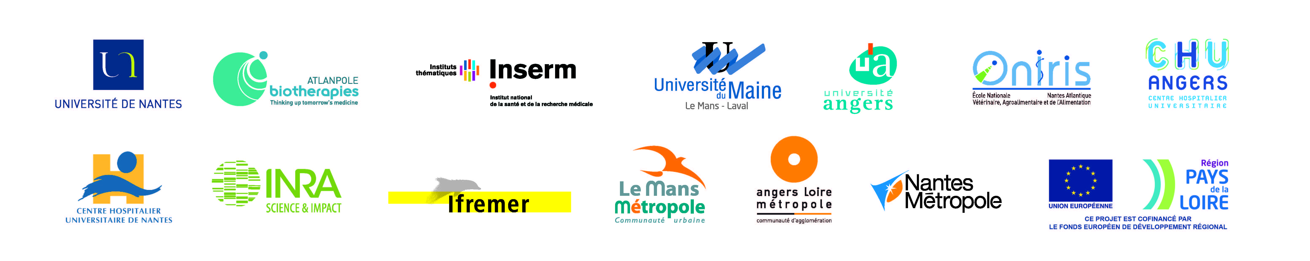

APPLICATION FILE

Completed application files will be submitted by the principal investigator by email to nissrine.mekkaoui@univ-nantes.fr. They must be accompanied :
- by all visas and reasoned opinions
- CV of the PI
- CV of the post doctoral student and a reference letter from his/her latest supervisor
- post doctoral student employment contract (if ready)
- the present application file

  - Proposal Identification file

Name of the proposal:
Acronym:
Duration of project:
Start date:
End date:
Total cost of proposal (excluding recurring expenditure; pre-VAT):
Sollicitated contribution from Bioregate (pre-VAT):

Scientific coordinator (please don’t forget to join a CV):
- First name:
- Surname:
- Laboratory of affiliation:
- Team:
- Labelling (please specify the AERES assessment):
- Contact details:

Institution in charge of the budget and administrative management of the proposal, setting-up and monitoring of the agreement /funding notification:
- Name of the institution
- Address
- Name of the signatory of the official document
- Contact details of the grant manager

Associated partners (Associated partners are partners contributing to the project but not receiving any Bioregate grant (international lab, other Pays de la Loire lab or optionally firm, lab based outside Pays de la Loire, etc.):

Associated partner 1 (from abroad and associated to Bioregate strategic international strategy):
- Name and details of the Principal Investigator (PI):
- Name of laboratory / Research team:
- Institution affiliated to for the management of the Bioregate budget project involving the post doc applicant:
- Name and contact details of the person in the leading institution:

Associated partner 2 (other Pays de la Loire region lab or organization):
- Name and details of the co-applicant:
- Name of laboratory / Research team:
- Name and contact details of the person in the leading institution:

Summary of the proposal (maximum 400 words)
This summary could be posted on the Bioregate website in the event of funding of the proposal and could be transmitted to the external expert(s). It must include namely:
- The framework of current positioning
- Proposal objectives
- Expected results
- Methodology

Key words associated with the proposal (5 maximum)

  - Proposal description and its matching with the objectives of the present call

- Subject of the proposal (3 lines max.)

- Consortium (400 words max.)
      - In what way is the association of expertise applied in this proposal complementary and cutting edge?
      - Are the partners initiating their 1st collaboration?

- Scientific and technical of the project (maximum 1500 words for this section). A Gantt chart is recommended
State of the art description of the research on the subject areas of the proposal
- Scientific objectives
- Operational focuses
- Implementation schedule (deliverables and recruitments)
- Results expected

- Post doctoral student profile (1 page max.)
- Post doctotral student identity:
- Short Biosketche:
- PhD held from: xx/xx/xxxx
- Last host lab(lab name and type of work achieved there):
- Description of the link with a Bioregate strategic international partner:
- Rare or specific brought skill(s) and impact on the host lab:
Please don’t forget to join a CV. A reference letter is a positive element.

- Stakes and perspectives of the project for the host lab, Bioregate cluster and its players (800 words max.)

- Stakes for the Bioregate cluster
How will this proposal benefit to your lab and/or Bioregate cluster in terms of research and international or European development and renown?

- Project perspectives: value-creation plan and perspectives of subsequent fundings
  - Economic value-creation perspectives (intellectual property, transfer of technology, provision of services, public/private partnerships directly related to the results of the present proposal, hiring a value-creation engineer, development of technology demonstrator/prototype, strategic positioning study of the scientific findings with a view to developing further start up company creation, in course training etc.)?

  - Academic value-creation perspectives

  - What kind of relationship could be envisaged to maintain the link with the post doctoral student and the international partner lab? Are further collaborations already planned?

- Success indicators of the project
In order to measure the benefits of the project in terms of results and scientific positioning, monitoring and assessment indicators must be proposed. Please specify 3 quality indicators relating, for example, to the expected structuring effects, the qualitative leap expected, the modalities of sustainability of the tools, etc.

“The proposal has reached its goals if…”

Indicators | Objective at project end

The indicators proposed by the principal investigator consort with indicators specific to the Bioregate framework, in particular with the assessment of the leverage effect of the Bioregate grant upon more competitive funding, regional employment and international attractiveness of Bioregate members.

  - Suggested reviewers

In order to shorten the processing time of the files and extend the reviewers’ data base, the principal investigator can list the names of at least 5 experts outside Pays de la Loire and non-members of the Bioregate network apt to conduct the assessment of the proposal. These reviewers can be French, European or international.

Reviewers selection must not raise conflict of interest: on-going collaborations, co-publications or direct competition. Non-fulfilment of this rule might halt the evaluation process or the funding if the project has already started. Additionnal external reviewers will be sollicitated by the steering committee.

Surname – First name | Discipline | Laboratory | Institution of affiliation | Mail

The principal investigator can also provide the names of researchers or research teams not suitable to review their grant, for conflict of interest reasons.

Surname – First name | Discipline | Laboratory | Institution of affiliation

  - Proposal cost and funding plan

Please remember that the proportion of the Bioregate grant must not exceed 68 749.5 € of the total cost of the proposal and must be dedicated to a post doctoral student wage

The table must describe the main components of the proposal funding plan as a whole and exclusive of tax: Bioregate grant + acquired or not co-funding + own funds

Category | Description | REI Funding | Project Leader’s Unit Funding | International partner funding | Other funding | Total Funding

  - Signatures

Visa of approval of the proposal scientific coordinator
Surname, First name, date and signature of the proposal coordinator with the words “read and approved”

Visa of approval and reasoned opinion of the laboratory director
Surname, first name, date and signature of the head of the investigator laboratory with the words “read and approved”

Visa of approval and reasoned opinion of the Director of the Institution
Surname, first name, date and signature of the head of the leading institution with the words “read and approved”

Please do not forget to annex the letter of commitment of the international partner.

